# Map View

It is the map view of application; user can do several activities on the map.

* User can see near about property for rent and sell on the map.
* User can view the property information by tapping on property icon.
* User can also search the property by tapping on the search bar.
* User can filter property .

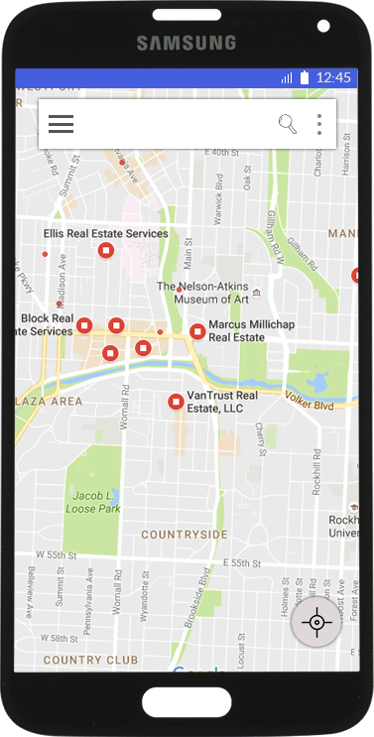

# Property information:

* User can see the basic information about the property from here.
* User can see the all required information like price, area, type of house on the same view (without going to another view).
* User can see detailed description about the property by taping on anywhere on the property information screen.

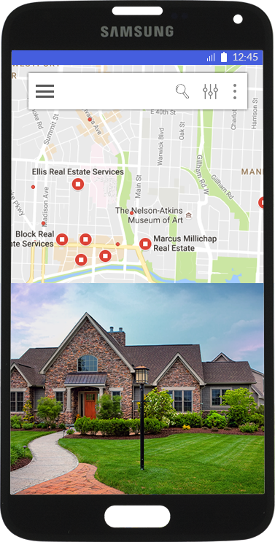

# Property Description:

Property description is the page from where user can see the all information about the property.

* At the top of this screen an automated slide of images will appear, user can navigate through the images to see the all slides.
* At the mid of screen, user can find all the information about property like description, key facts, additional information.
* User can see the street view or can find the direction of place.
* User can also share the property detail with others using the different social media platform.
* At the bottom of the screen, user will get a contact form, where he/she can submit the form after filling the all required detail. User can also see the property owner’s detail.
* User can also mark the property as favorite after taping the heart icon. User can see all favorite property later.

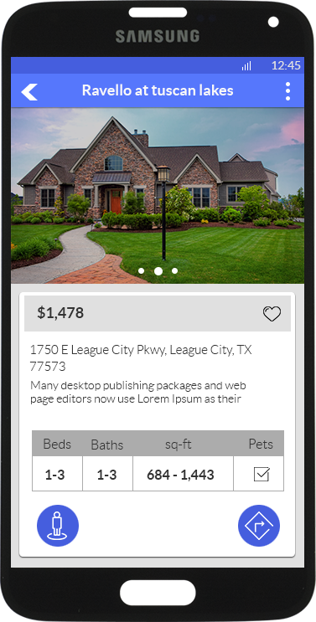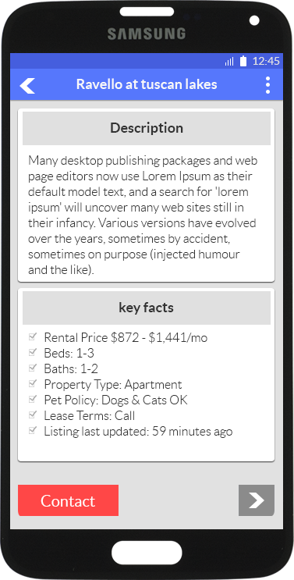 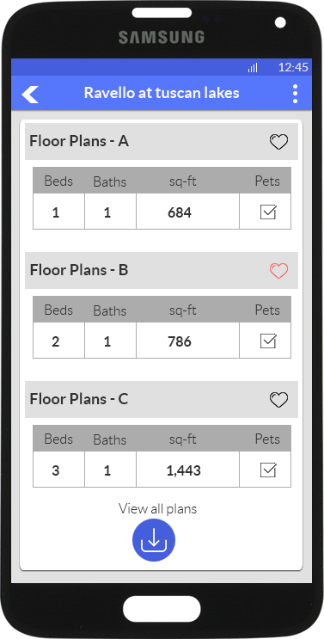

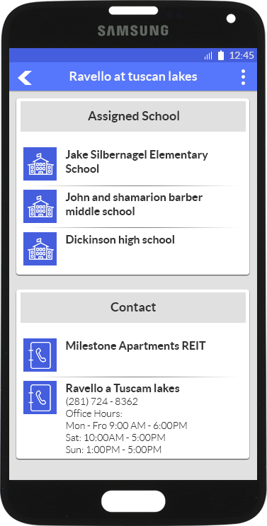

# Property List View:

* User can also browse the property as list view.
* List view will show only the basic information about the property user needs to tap on the property to see the detailed description about the property.
* User can filter the detail of property by tapping on the filter icon.
* User can sort the property by tapping on the sort icon.
* User can mark property as favorite.

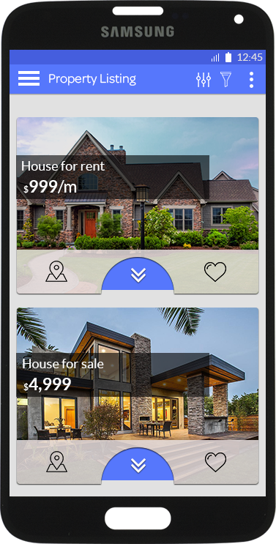 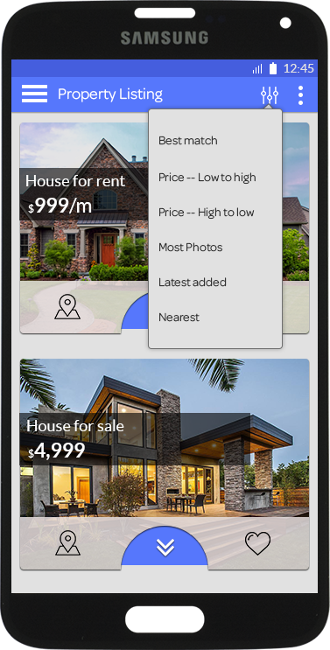

# Favorite List:

User can see all property, which he or she has marked as favorite from here.

# Login

User can do login in app.

# Sign Up:

User can do signup in app.

**USERS:**

|  |  |  |  |
| --- | --- | --- | --- |
| S.No# | Column Name | Data Type | Description |
| 1 | user_id | INT | Primary key |
| 2 | email | varchar | Unique |
| 3 | password | varchar | password for user login. |
| 4 | user_type | varchar | Buyer/Seller |

**BUYERS:**

|  |  |  |  |
| --- | --- | --- | --- |
| S.No# | Column Name | Data Type | Description |
| 1 | user_id | INT | Primary key |
| 2 | fname | varchar | Firstname |
| 3 | lname | varchar | lastname |
| 4 | country | varchar | represents the nation. |
| 5 | state | varchar |  |
| 6 | city | varchar |  |
| 7 | zip | int |  |
| 8 | contact | big int | contact number |

## 

**Favourite property:**

|  |  |  |  |
| --- | --- | --- | --- |
| S.No# | Column Name | Data Type | Description |
| 1 | user_id | INT | Primary key |
| 2 | property_id | INT |  |

**PROPERTIES:**

|  |  |  |  |
| --- | --- | --- | --- |
| S.No# | Column Name | Data Type | Description |
| 1 | property_id | INT | Primary key |
| 2 | seller_id | int |  |
| 3 | title | varchar |  |
| 4 | price | varchar |  |
| 5 | type | varchar |  |
| 6 | description | varchar |  |
| 7 | location | varchar |  |
| 8 | lat | float | latitude |
| 9 | long | float | longitude |

## 

**Specifications:**

|  |  |  |  |
| --- | --- | --- | --- |
| S.No# | Column Name | Data Type | Description |
| 1 | proprty_id | INT | Primary key |
| 2 | bed | int | Firstname |
| 3 | bathroom | varchar | lastname |
| 4 | sqft | varchar | represents the nation. |
| 5 | acre_lot | varchar |  |
| 6 | interior_feature | varchar |  |
| 7 | exterior_feature | int |  |
| 8 | heating_feature | big int | contact number |
| 9 | roofing | varchar |  |
| 10 | exterior_construction | varchar |  |
| 11 | room_desc | varchar |  |
| 12 | unit_feature | varchar |  |
| 13 | school | varchar |  |
| 14 | garage_parking | varchar |  |
| 15 | stories | varchar |  |

**Additional Details:**

|  |  |  |  |
| --- | --- | --- | --- |
| S.No# | Column Name | Data Type | Description |
| 1 | property_id | INT | Primary key |
| 2 | listing_agent | varchar |  |
| 3 | listing_by | varchar |  |
| 4 | broker | varchar |  |
| 5 | data_source | varchar |  |
| 6 | source_property_id | varchar |  |
| 7 | source_copyright | int |  |

## 

**Tax History:**

|  |  |  |  |
| --- | --- | --- | --- |
| S.No# | Column Name | Data Type | Description |
| 1 | property_id | INT | Primary key |
| 2 | year | varchar |  |
| 3 | tax_paid | varchar |  |
| 4 | total_assessment | varchar |  |
| 5 | source | varchar |  |

## 